Tatiana Case

February 25th, 2024

CS-330

7-1 Final Project Reflection

Design Decisions

For my final project I have chosen 4 3D randomly placed 3D objects to recreate. I specifically chose these items because they bring me joy. The character in the center is from the movie The Nightmare Before Christmas and that has been one of my favorite films since childhood. This specific figure sits on my desk and is a constant companion when I am doing schoolwork. The plastic food items remind me of my two-year-old daughter who is constantly trying to sell me fake food. Finally, the centered bead reminds me of my eldest daughter who enjoys making me custom made plastic jewelry. Initially, these objects looked simple to duplicate, but I did have some difficulties along the way.

As most of these assignments in this course, I began by rendering the shapes in the scene. Luckily, my objects were geometrical. So, they were simply built using the basic shape meshes provided to us by Professor Brian. For simplicity’s sake, I kept all the function names the same and just rendered multiples of each shape where necessary. For example, the Vampire Teddy contains 8 strategically placed cylinders, a tapered cylinder, and 3 spheres. This is by far my most complex object. The hot dog bun consists of a large cylinder and one sphere at each end. The hot dog bun is built in the same manner. The donut is two tori stacked on one another. This design decision was made because the chocolate icing texture that I originally planned to use was not wrapping around the main torus properly. I also manipulated the thickness of the tori by changing its scale in the meshes.cpp.

Processing user input to manipulate the camera was a very important part of my design process. I wanted to make sure that I included all the rubric requirements while making it easy for the user to navigate all angles of my scene. The most difficult part for me was implementing the “P” and “O” keys for the different perspectives. Adding the key input was simple but the function was difficult for me to get working properly. See below for the perspective function and the accompanying key inputs.

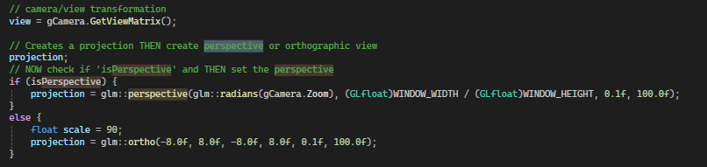

One thing that I customized was the camera speed. I made sure that when the mouse wheel was spun, that the camera increased speed exponentially instead of a gradual increase. This is important because if the user is anything like me, then they would appreciate getting around the scene at a faster pace. See the below for my edit of the camera.h to implement the camera speed. Personally, I could have made the max faster, but I believe 10 was a happy medium.

To maintain organization, I wish I had made different header files and cpp files so that my source.cpp wasn’t so long. But before I realized I should make that change I was already in the texturing stage of my project, and it would have taken too much time. Instead, I just separated each object with note bracketing. Although my source.cpp file is long, each function is easily found by paying attention to my notes.

